Greetings, Ohio Advocate!

I hope 2022 is off to a good start! We are full steam ahead working on our legislative priorities for the year and I am excited to update you as we make progress towards our goals and look forward to working alongside you toward them.

Important Dates:

- Saturday, January 29th (10am – 1pm ET): Annual Advocacy Training. REGISTER TODAY!

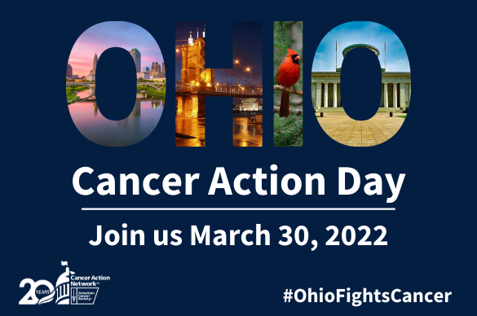
SAVE THE DATE!

Action Items:
- Register for the annual training on January 29th.
- Start thinking about your 2022 Lights of Hope plan and goals! It will be here soon (hint….hint)
- Check out the NEW ACS CAN Volunteer Home Page: www.fightcancer.org/volunteerhome

Your Email is also linked HERE
In This Email:
- New ACS CAN Volunteer Home Page
- State Update
- Federal Update
- Advocacy Training
- Ambassador Action Center
- Story Collection

ACS CAN Volunteer Home Page
The National ASC CAN Volunteer page has launched on the fightcancer.org website. Click the link above in “Action Items” to see some of the amazing new resources just for YOU! This page is a hub for you to find many of the resources that will make you wildly successful in your advocacy work. The page has several features and resources:
- GET STARTED – Links to the Volunteer Community, onboarding training, materials, and the Ambassador Action Center (AAC).
- CONNECT you with your TEAM – links to the 2022 National volunteer call schedule, volunteer position descriptions and partnership agreements.
- IMPACT LAWMAKERS – Links to find your lawmakers and complete a congressional district analysis.
- EARNED MEDIA & SOCIAL MEDIA – Links to ACS CAN Connections Facebook group, Patch.com, and more!
- FUNDRAISE – Links to LOH (Lights of Hope) Resource Page, fundraising resources, membership information, etc.

State Update…Got questions? Email leo.almeida@cancer.org
Redistricting
The Ohio Supreme Court rejected the proposed House and Senate maps in a 4-3 decision on Wednesday. This decision upholds the 2015 amendment to the Ohio constitution that would limit partisan line-drawing; also called gerrymandering. The group has ten days to redraw the state legislative maps to align with the population more closely. This extension of a final, approved map places the deadline close to the primaries which are scheduled for May 3.

HB122 – Telehealth Expansion
This important bill has been signed into law by the Governor as of the end of 2021. He is expected to have a ceremonial signing at the end of the month. This law will expand coverage and access to telehealth services which is critical for patients with compromised immune systems such as cancer patients.

2022 Legislative Priorities
As we work through our legislative priorities, one of the important issues we are excited to be jumping into is around access to biomarker testing. Biomarker testing is often confused with testing that can determine if an individual has a predisposition to cancer. Rather, biomarkers are identified AFTER a cancer diagnosis. These markers will then help identify which cancer mutation a patient has which then informs optimum treatment options. These tests are not universal, but when appropriate can reduce the cost and side effects that accompany treatment. To start learning more about this important priority, please watch this moving short video from Illinois who passed the first in the country model legislation in 2021. Watch the video HERE!

Federal Update…Got questions? Email robyn.kaltenbach@cancer.org
Build Back Better
Prior to adjourning in December, you may recall that Senate Majority Leader Chuck Schumer said during a private caucus call that a floor vote on the BBBA bill in January remains uncertain. The fate of the legislation is uncertain based on an opposition statement given by Senator Manchin. Last week, Schumer indicated that if Republicans block elections reform legislation when given another chance to take up that legislation, the Senate will hold a vote this week on rules changes designed to alter filibuster and allow debate (and possible passage to proceed). There was a lot of effort put into pressuring the Senate to not strike paid leave pre-emptively from the package.

Advocacy Training
Have you heard? Our annual training is even bigger and better! We’ve moved to a Tri-State Ambassador Summit to provide a richer, more meaningful experience. If you haven’t registered, do so today! We will start the morning with a very special guest to get us inspired and will be joined throughout the day by staff from the National Team to update us on our Federal wins and outlook as well as other key priorities for ACS CAN. We will then gather in smaller breakout sessions based on state and your area of interest. In addition to our special guests and informative sessions, we will have plenty of time to enjoy our morning together and you might even win a special prize! We have put in a ton of thought to make this session worthwhile, and I really hope to see you there!
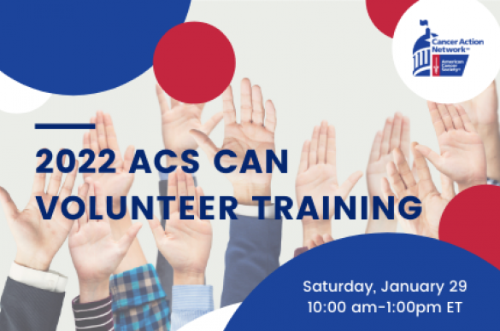

Ambassador Action Center (AAC)
Are you into New Years’ Resolutions? Why not challenge yourself to get to the top of the chart by following some of the actions designed to move our priorities forward. A wise volunteer from Indiana recently said: “you wouldn’t work 40 hours a week at a job and not turn in your timecard. Why would you work so hard to help save lives and not complete your timecard?”.

The updated AAC is much more user-friendly so check it out and record your actions TODAY:

Meanwhile, check out what these incredible folks logged already this month:

Julie Turner – Got media coverage
Barb Diver – Impacted Lawmakers
Pam Manges – Connected with partners & Impacted Lawmakers

Storytelling
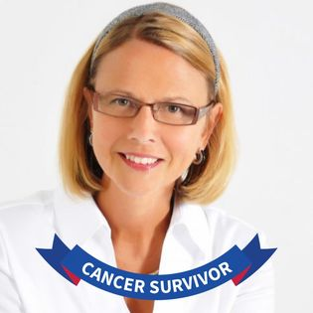
I am going to challenge our State to expand our story collection campaign this year. Making connections is a crucial strategy for getting key decision-makers to listen. It can also help develop relationships and in the healing process. As we move into the year of storytelling, I wanted to leave you inspired with Julie Turner’s recent story regarding her challenges with copay accumulators. Please take a few minutes to watch Julie’s story and start thinking about how you will share your story with us. I will be sharing more information on how you can share your story with us in the coming weeks so get ready! Do you know someone who benefited from Biomarker testing?

All stories are important. What is yours?

Julie’s Story

I look forward to sharing more about Cancer Action Day and our Legislative Priorities and how you can get involved in the coming weeks.

Meanwhile, be well my friends!

