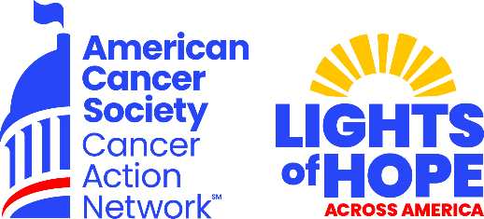

State Premier Sponsor - $10,000
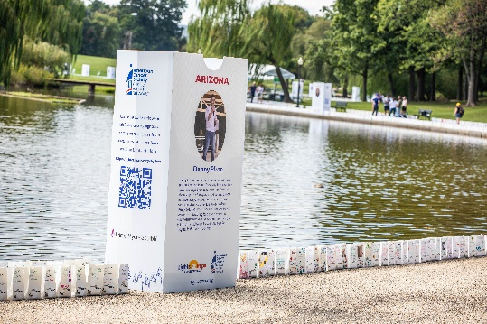
The displays in communities from coast to coast and
in our nation's capital will send a clear and impactful
message to lawmakers that fighting cancer must be a
national priority – from increasing funding for lifesaving
cancer research to ensuring that all Americans in all
communities have access to quality, affordable cancer
care.
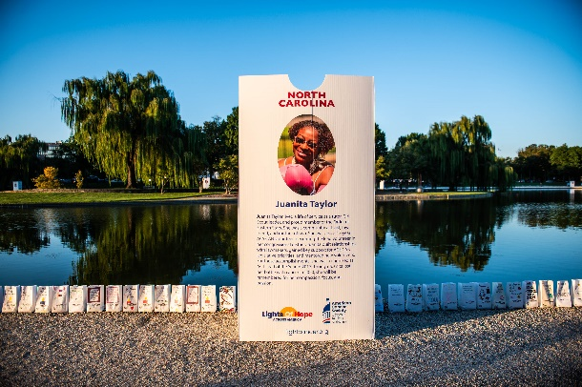
We invite your company to join with us in supporting
this moving event.

- Recognition Benefits:

Up to 250 Lights of Hope bags to be personalized
at the sponsors discretion

Logo featured on four lawn signs to be displayed
across your state

Logo recognition as STATE section sponsor at the DC
Hope Walk

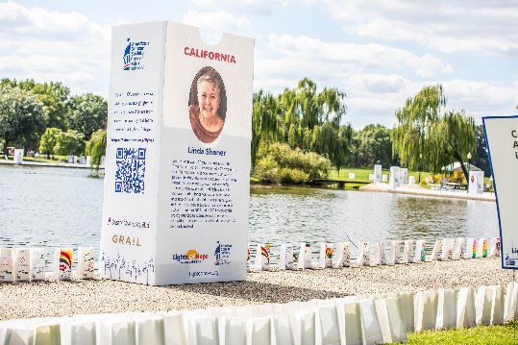
Recognition on ACS CAN STATE social media pages

Opportunity for name recognition in local press release

Recognition included in video compilation at DC hope
walk andWebsite

-Corporate Membership Benefits – Corporate Friend
- Issue briefings with ACS CAN Senior Leadership
- Complimentary invitation to annual National Forum on the Future of Health Care in Washington, DC
- Receive ACS CAN’s monthly outreach e-newsletter
- Recognition at ACS CAN’s headquarters, in annual Advocacy Accomplishments report and on the ACS CAN website

Contributions or membership payments to the American Cancer Society Cancer Action Network, Inc. are not tax deductible

