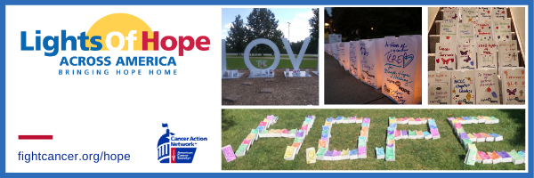
24 in 24 Hours Challenge
Template Language & Tips for Fundraisers

The challenge: Raise $240 online (24 Lights of Hope) in 24 hours!

We have created templates for you to post on social media, send via text message, or email to potential donors to promote the challenge. Please edit this language to fit you and your story. We also encourage you to post photos of your own lights of hope to form a personal connection with donors.

There are five templates to use throughout the 24 hours. We recommend downloading them on your computer or phone to prepare for the challenge.

Social media tips:
- Include the donation link in the comments of your Facebook post or in your Instagram bio.
- Each time you receive a donation, thank that person on social media, share how close you are to your $240 goal, and send your link again.
- You may tag friends and followers to nominate them for the challenge. You can tag them on the template image, in the caption, or in the comment section.
Social media posts:

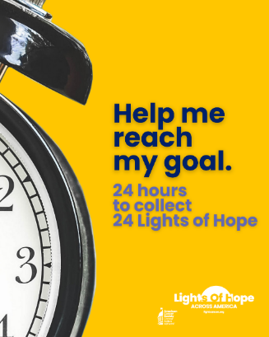
- To kick off the challenge, post this template.

Sample Twitter/X Caption (280-character limit): Help me raise $240 donations in 24 hours for ACSCAN’s Lights of Hope and honors someone who has been touched by cancer. Donate today! (your personal URL)

Sample Instagram or Facebook Caption: This year, I am participating in ACS CAN’s 14th annual Lights of Hope event. Today is the 24 in 24 challenge! My goal is to raise $240 in the next 24 hours to honor those affected by cancer. Lights of Hope is a special event because… (add personal touch/story). To donate, please use the link in my bio!

- About 6 hours into the challenge, post this template. In the caption, provide some background information on the ACS CAN mission and the Lights of Hope event.

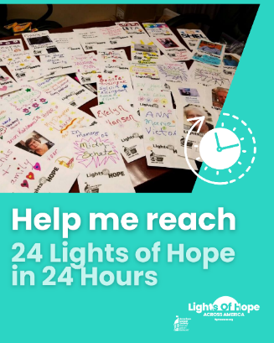

Sample Twitter/X Caption (280-character limit): Lights of Hope is a signature @ACSCAN event. Every Lights of Hope bag honors a loved one touched by cancer and sends a powerful message to lawmakers. Use the link in my bio to help me raise $240 in 24 hours for the Lights of Hope 24 in 24 challenge.

Sample Instagram and Facebook Caption: Lights of Hope is a signature @ACSCAN event. Every Lights of Hope bag honors and remembers a loved one touched by cancer. The event also sends a powerful message to lawmakers that the fight to end cancer is far from over. Use the link in my bio to help me raise $240 in 24 hours for the Lights of Hope 24 in 24 challenge.

- 12 hours into the challenge, post this template. This post marks halfway through the challenge. Update your followers on your progress. If you have another personal story to share, consider adding it the caption for this post.

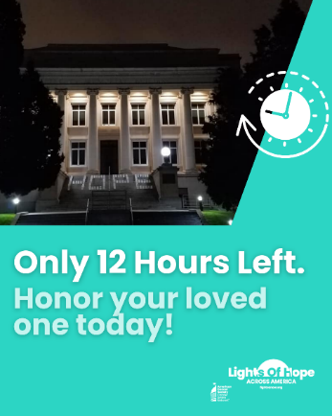

Sample Twitter/X, Instagram, or Facebook Caption: We are halfway through the 24 in 24 challenge. There are 12 hours left to donate to my page, and I still need X donations to meet my goal.

- When there are only a few hours left in the challenge, post this template. This is the last reminder and push for donations.

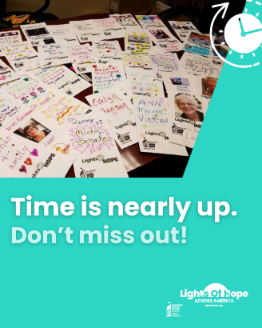

Sample Twitter/X, Instagram, or Facebook Caption: REMINDER: There are only X hours left to donate to my page for the 24 in 24 challenge. I only need X donations to meet my goal.

- At the end of the 24 hours, post this template. Share your final donation amount and thank your followers for participating.

Sample Twitter/X, Instagram, and Facebook Caption (challenge completed): Thank you for your support! Together, we completed the 24 in 24 challenge, and we raised X donations for Lights of Hope and @ACSCAN.

