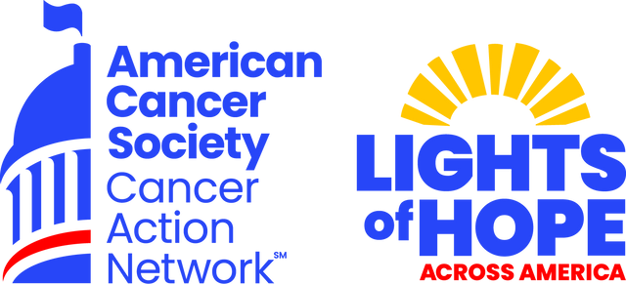

SEPTEMBER 2025

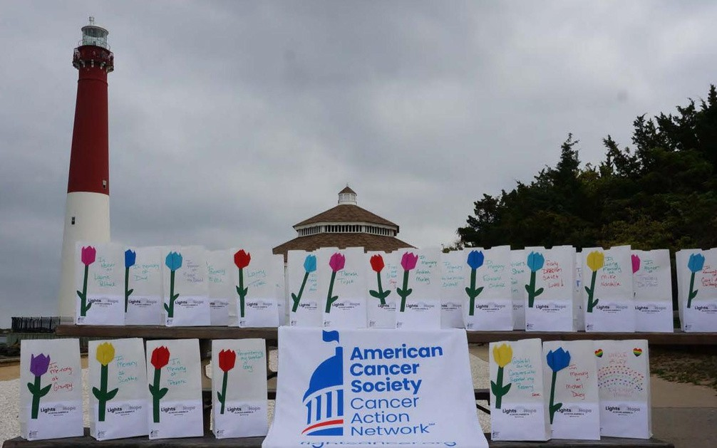

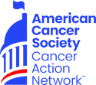PARTNERSHIP OPPORTUNITIES

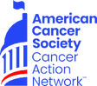The American Cancer Society Cancer Action Network (ACS CAN) makes cancer a top priority for policymakers at every level of government. ACS CAN engages volunteers across the country to make their voices heard to ensure that our cities, our states and our nation adopt evidence-based policies that improve the lives of people with cancer and their families. We believe everyone should have a fair and justice opportunity to prevent, detect, treat, and survive cancer.



What is ACS CAN?

Since 2001, as the American Cancer Society’s nonprofit, nonpartisan advocacy affiliate, ACS CAN has successfully advocated for billions of dollars in cancer research funding, expanded access to quality affordable health care, and advanced proven tobacco control measures. We stand with our volunteers, working to change public policy to end cancer as we know it for everyone.

 Medicaid Covers Us



Our Priorities

Cancer Research Funding

 Access to Healthcare  Cancer Prevention

 Tobacco Control

 Reducing Health Disparities

 Patient Quality of Life



Our Impact

## 62.3%

of the U.S. population protected from secondhand smoke exposure by local or statewide smoke-free laws.

**33%**

decline in cancer death rates from 1991-2021

## 33.5 million

people benefited from expanded access to health insurance

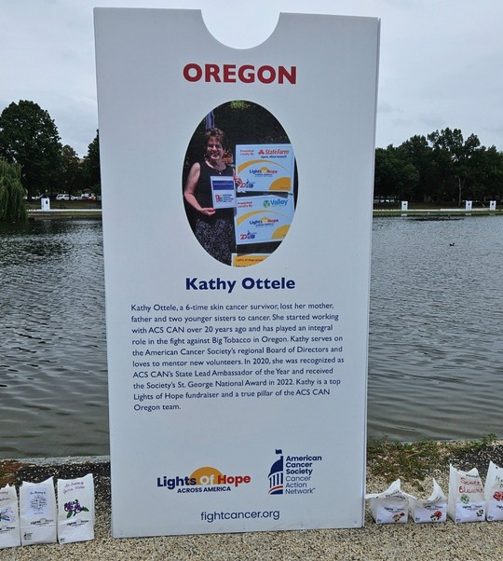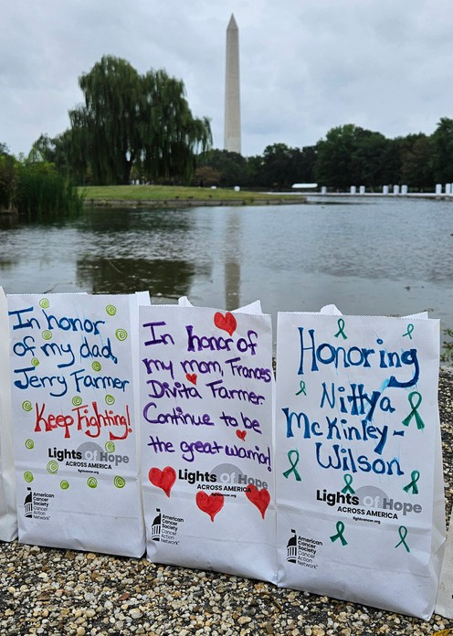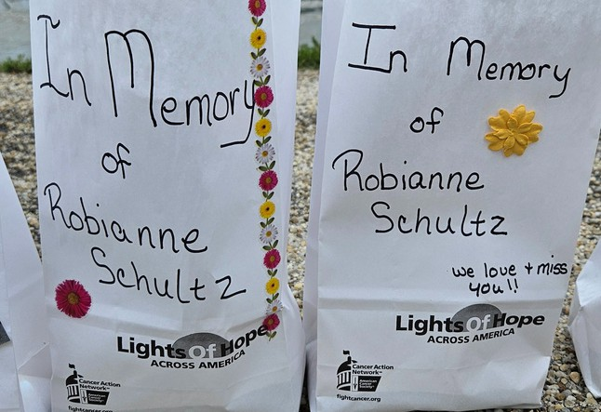

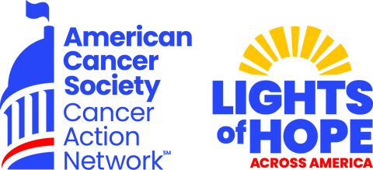



The Event

In September 2025, the American Cancer Society Cancer Action Network (ACS CAN) will host its 15th annual Lights of Hope event. Each Light of Hope honors loved ones who have survived cancer and remembers those we’ve lost.

The displays in communities from coast to coast and in our nation’s capital will send a clear and impactful message to lawmakers that fighting cancer must be a national priority – from increasing funding for lifesaving cancer research to ensuring that all Americans in all communities have access to quality, affordable cancer care.

A look back at 2024:

 We displayed over 80,000 Lights of Hope at hundreds of at-home displays

 We raised over $834,225

2.8 thousand posts using #lightsofhope on our social media

 189 television hits on Lights of Hope

This event is very powerful and meaningful to all. Your support will help us light hope across America.

We invite you to support the Lights of Hope event in the following ways:

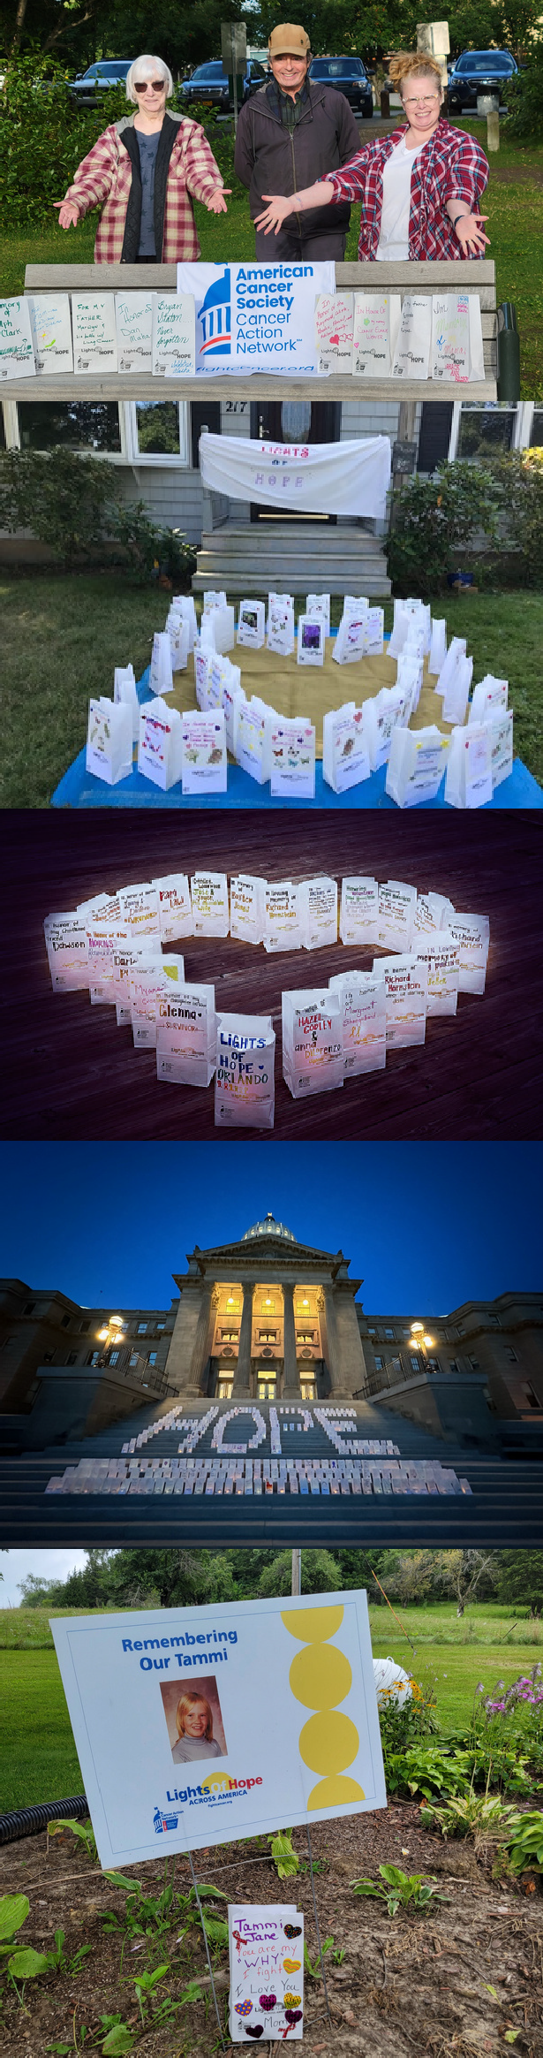

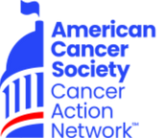

Sponsorship Opportunities

# State Premier Sponsor | $10,000

Up to 250 Lights of Hope bags to be personalized at the sponsors discretion

Logo featured on four lawn signs to be displayed across your state

Logo recognition as STATE section sponsor at the DC Hope Walk

Recognition on ACS CAN STATE social media pages Opportunity for name recognition in local press release Recognition included in video compilation at DC hope walk, on the Lights of Hope website.

Recognized as a Corporate Friend in ACS CAN’s Corporate Membership Program.

 Issue briefings with ACS CAN Senior Leadership

 Complimentary invitation to annual National Forum on the Future of Health Care in Washington, DC

 Receive ACS CAN’s monthly outreach e-newsletter  Recognition in ACS CAN’s annual Advocacy

Accomplishments report and on the ACS CAN website

# Champion Sponsor | $5,000

 Up to 200 Lights of Hope bags to be personalized at the

sponsors discretion

 Logo featured on four lawn signs to be displayed across your state

 Logo Recognition on ACS CAN STATE social media pages  Opportunity for name recognition and at DC Hope Walk

and in local press release

 Opportunity to speak at local event, where applicable  Recognized as a Corporate Sponsor in ACS CAN’s

Corporate Membership Program.

 Issue briefings with ACS CAN Senior Leadership

 Receive ACS CAN’s monthly outreach e-newsletter  Recognition in ACS CAN’s annual Advocacy

Accomplishments report and on the ACS CAN website.

# Diamond Sponsor | $2,500

 Up to 150 Lights of Hope bags to be personalized at the sponsors discretion

 Logo featured on two lawn signs to be displayed in your community

 Logo Recognition on ACS CAN STATE social media pages  Recognition in ACS CAN's annual Advocacy

Accomplishments Report and at DC Hope Walk

 Opportunity for name recognition in local press release

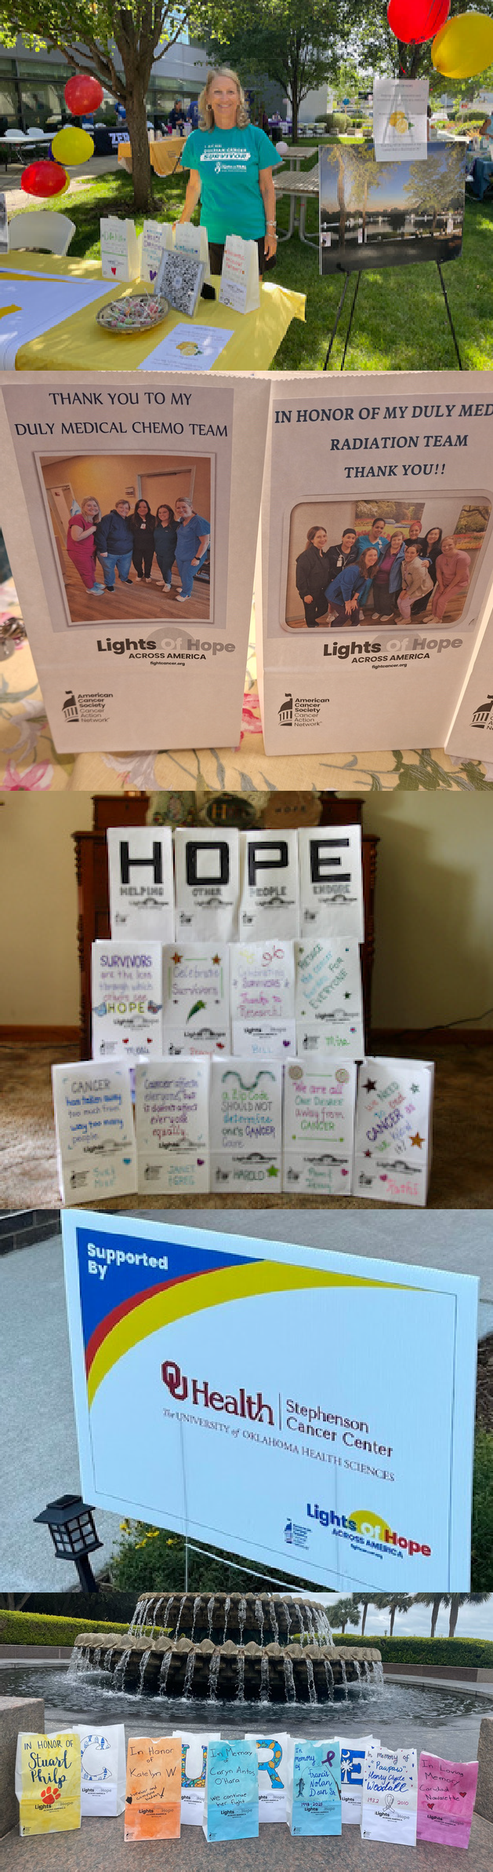Sponsorship Opportunities Cont.

# Platinum Sponsor | $1,000

 Up to 100 Lights of Hope bags to be personalized

 Logo featured on two lawn signs to be displayed in your community

 Logo Recognition on ACS CAN STATE social media pages  Recognition in ACS CAN's annual Advocacy

Accomplishments Report and at DC Hope Walk

 Opportunity for name recognition in local press release

# Gold Sponsor | $500

 Up to 50 Lights of Hope bags to be personalized

 Logo featured on lawn sign to be displayed in your community

 Logo Recognition on ACS CAN STATE social media pages

 Recognition in ACS CAN's annual Advocacy Accomplishments Report

# Silver Sponsor | $350

 Up to 35 Lights of Hope bags to be personalized

 Name featured on lawn sign to be displayed in your community

 Name Recognition on ACS CAN STATE social media pages  Recognition in ACS CAN's annual Advocacy

Accomplishments Report

# Bronze Sponsor | $200

 Up to 20 Lights of Hope bags to be personalized  Recognition on ACS CAN STATE social media



Family Sponsor | Starting at $350

Families can come together and sponsor your at-home event. As a family, you can place a photo of a loved one and the family name in place of a logo. The family would receive the benefits at the appropriate level.

Contributions or membership payments to the American Cancer Society Cancer Action Network, Inc are not tax deductible.