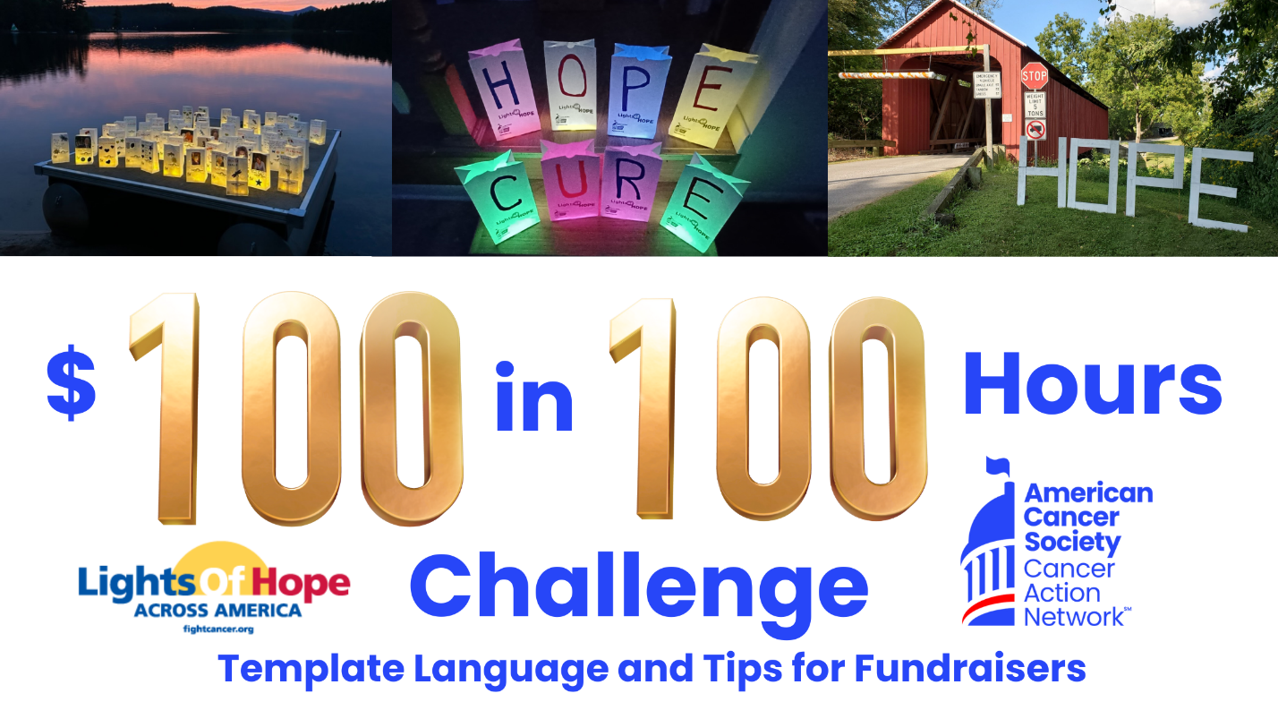
The Challenge: Raise $100 in 100 Hours

We have created templates for you to post on social media, send via text message, or email to potential donors to promote the challenge. Please edit this language to fit you and your story. We also encourage you to post photos of your own lights of hope to form a personal connection with donors.

There are particular templates for the start, 12 hours left, and end of the challenge. There six other templates to use at your discretion. We recommend downloading them on your computer or phone to prepare for the challenge.

Social media tips:
- Include the donation link in the comments of your Facebook post or in your Instagram bio.
- Each time you receive a donation, thank that person on social media, share how close you are to your $100 goal, and send your link again.
- You may tag friends and followers to nominate them for the challenge. You can tag them on the template image, in the caption, or in the comment section.

Social media posts:

- To kick off the challenge, post this template.

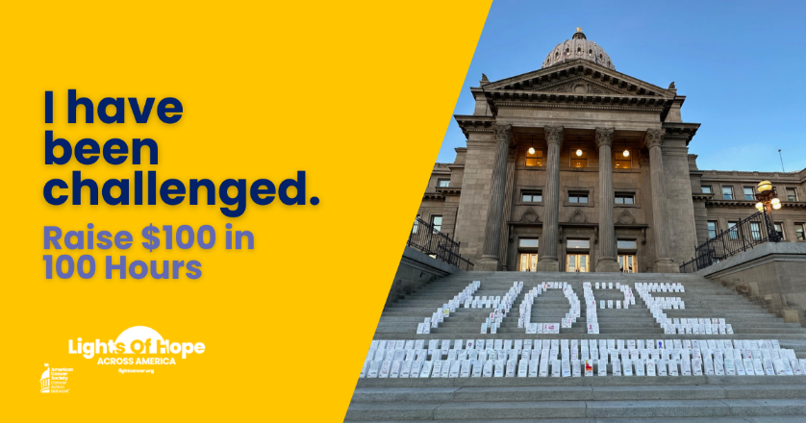

Sample Twitter/X Caption (280-character limit): Help me raise $100 of donations in 100 hours for ACSCAN’s Lights of Hope and honor someone who has been touched by cancer. Donate today! (your personal URL)

Sample Instagram or Facebook Caption: This year, I am participating in ACS CAN’s 14th annual Lights of Hope fundraising event. Today is the $100 in 100 hours challenge! My goal is to raise $100 in the next 100 hours to honor those affected by cancer. Lights of Hope is a special event because… (add personal touch/story). To donate, please use the link in my bio!

- Remind your followers by posting everyday of the challenge. To do so, use any of these templates. In the caption, provide some background information on the ACS CAN mission and the Lights of Hope event. You may also provide a fundraising update.

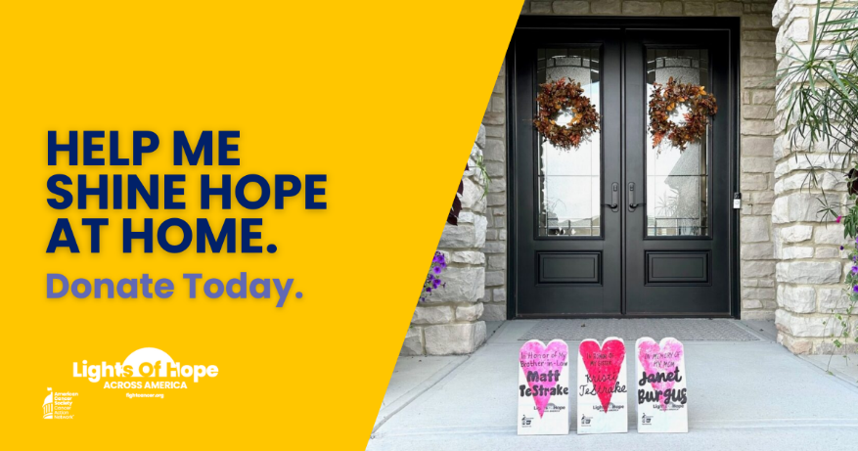

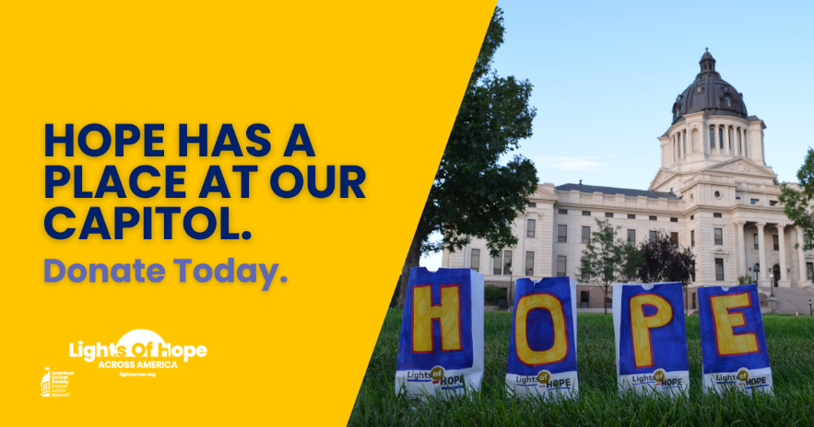

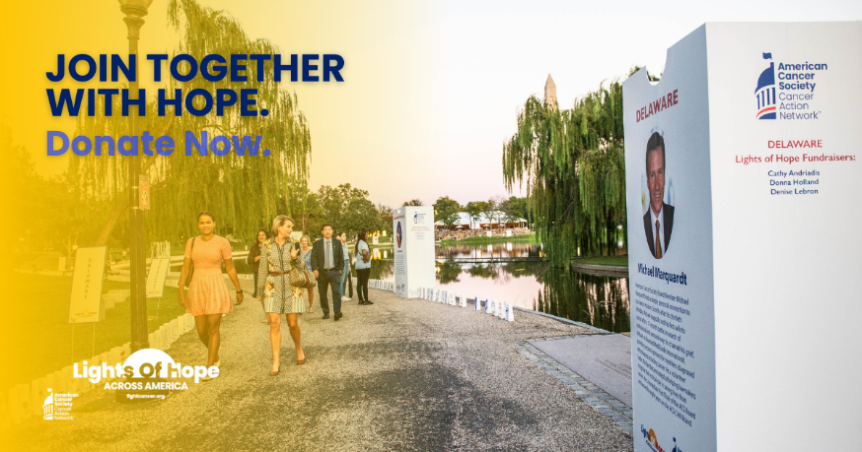

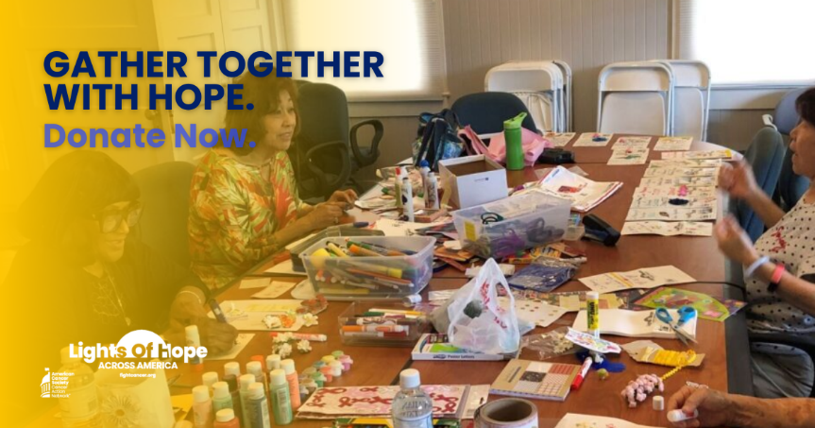

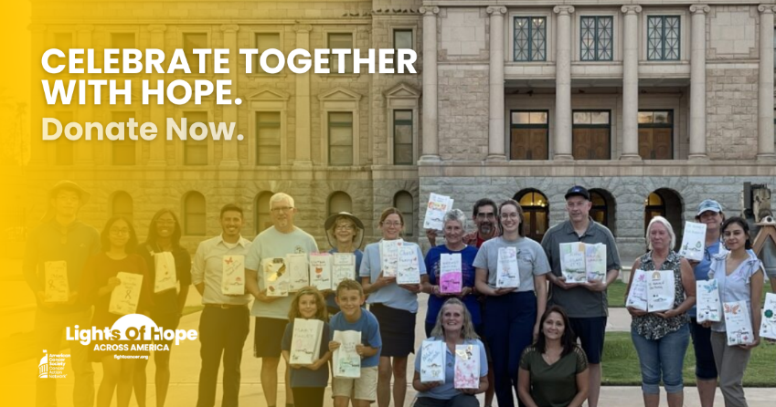

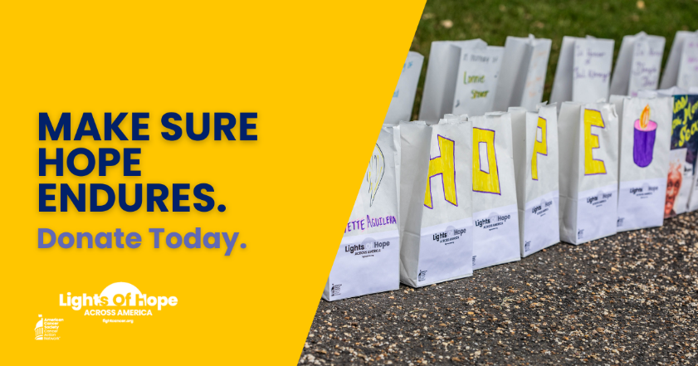

Sample Twitter/X Caption (280-character limit): Lights of Hope is a signature @ACSCAN event. Every Lights of Hope bag honors a loved one touched by cancer and sends a powerful message to lawmakers. Use the link in my bio to help me raise $100 in 100 hours for the Lights of Hope 100 in 100 challenge.

Sample Instagram and Facebook Caption: Lights of Hope is a signature @ACSCAN event. Every Lights of Hope bag honors and remembers a loved one touched by cancer. The event also sends a powerful message to lawmakers that the fight to end cancer is far from over. Use the link in my bio to help me raise $100 in 100 hours for the Lights of Hope 100 in 100 challenge.

- When there are 12 hours left, post this template. This is the last reminder and push for donations.

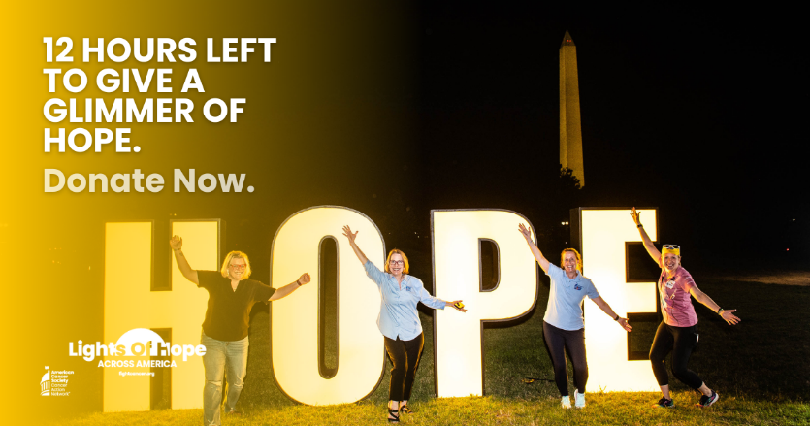

Sample Twitter/X, Instagram, or Facebook Caption: REMINDER: There are only 12 hours left to donate to my page for the $100 in 100 hours challenge. I only need X donations to meet my goal.

- At the end of the 100 hours, post this template. Share your final donation amount and thank your followers for participating.

Sample Challenge Completed Twitter/X, Instagram, and Facebook Caption: Thank you for your support! Together, we completed the $100 in 100 hours challenge, and we raised X donations for Lights of Hope and @ACSCAN.

Sample Challenge Not Completed Twitter, Instagram, and Facebook Caption: Thank you for your support! Together, we raised X donations in 100 hours for Lights of Hope and @ACSCAN.

