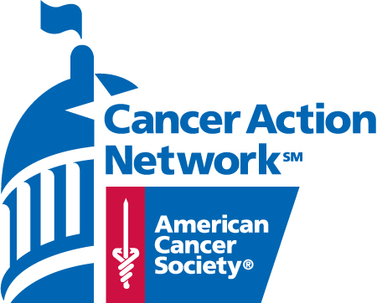
FOR MORE INFORMATION, CONTACT:
Hilary Schneider, State Director of Government Relations and Advocacy
207.373.3707 (o), 207.522.1332 (c)
hilary.schneider@cancer.org

Senator Snowe Receives National Distinguished Advocacy Award

Award is highest honor bestowed by the American Cancer Society Cancer Action Network

Portland, Maine – September 18, 2012 – Senator Olympia Snowe has been awarded the National Distinguished Advocacy Award, the most prestigious honor bestowed by the American Cancer Society Cancer Action Network (ACS CAN) in recognition of the Senator’s years of relentless commitment to sustaining and increasing investments in federal funding for cancer research, prevention and detection.

The annual award is given by ACS CAN, the advocacy affiliate of the American Cancer Society, to select lawmakers who demonstrate solid, consistent leadership in the area of cancer-related public policy advocacy.

“Senator Snowe has been a champion of cancer prevention efforts for the people of Maine,” said Chris Hansen, president of ACS CAN. “With her unwavering commitment to fighting cancer through the power of public policy, Senator Snowe has positioned Maine as a forerunner in the realm of public health.”

Senator Snowe’s strong leadership in promoting cancer prevention and early detection through public policy is evidenced in part by cosponsoring the National Breast and Cervical Cancer Early Detection Program Reauthorization Act of 2007 and the Family Smoking Prevention and Tobacco Control Act in the 110th Congress.

In addition, Senator Snowe has demonstrated tremendous leadership and grace in working to develop bipartisan policy proposals to expand access to health coverage, especially for seniors and low-income Mainers and Americans. In the 110th Congress, she was a cosponsor of Michelle’s Law, which allows full-time college students to take up to 12 months medical leave without losing health insurance coverage. Senator Snowe took the lead on legislation enacted in 2008 banning discrimination in jobs and health insurance based on the results of genetic testing. This had been an effort she had worked to advance for more than a decade.

“On behalf of all those who have been touched by cancer, the American Cancer Society Cancer Action Network applauds Senator Snowe’s passion and determination to enact meaningful legislation that saves countless lives from the disease,” said Jeff Bennett, a Maine ACS CAN volunteer who presented the Senator with the award in Washington, D.C., last week.

ACS CAN is the nonprofit, nonpartisan advocacy affiliate organization of the American Cancer Society, dedicated to eliminating cancer as a major health problem. ACS CAN works to encourage lawmakers, candidates and government officials to support laws and policies that will make cancer a top national priority. ACS CAN gives ordinary people extraordinary power to fight cancer. For more information, visit www.acscan.org.

###

